WHHOA Board Meeting Minutes
May 9, 2022, 7:00 PM
In Person at Clubhouse
Board Member Attendees: Steve Ryan, president; Bill Logan, Vice President; Jeff Rooks, Treasurer, Patricia Ryan, Secretary; Finis McCarver, Director
Absent: 0
Committee Member Attendees: 3
Community member attendees: 3

- Call meeting to order/Agenda overview

- Public Comment:

  - Two residents asked for assistance with an issue they are having. The board offered some advice.
  - A resident complimented the new walkway and thanked the board for getting it done.

- Consent Calendar
- Approval of previous minutes- Minutes of the April 2022 board meeting were approved unanimously.

- Financial Report-Jeff Rooks. See report below

- Committee Reports

- Pool-Dorothy Minter chair.
  - The pool deck will need to be resurfaced by next summer. The board approved a partial payment in the fall to lock in cost and to assure that the deck is completed before pool opening 2023.
  - The cracked housing in one of the pool pumps has been repaired
  - Key cards are activated for use: 6:00 am to 11:00 pm.
- Welcome –Whitney Meyer chair.
  - Two homes have been sold and one is pending. One of the homes sold was to Open Door for rental purposes.
- Landscape- Bill Logan chair.
  - This Friday, May 13, dirt will be placed along the sides of the new walkway, which will allow Sprinkalawn Co. to reinstall sprinkler heads to an appropriate height.
  - The owner of the landscape company has been given a key to access pool and irrigation systems. The owner reported that work may be slowed because of difficulty maintaining staff.
  - 2 bushes were damaged during the Easter Egg hunt
  - Flowers will be planted within 2 weeks -$975.00

- ACC-Bill Logan chair.
  - The committee is researching companies to provide replacement mailboxes and mailbox parts.
- Tennis- Jamey Linard chair. See report below

- Social-Debbie Ladin chair.

  - We had the Easter egg hunt, 111 rsvp’s, with additional people
We spent $127.18 on supplies.

  - The first Ladies Night is this Wednesday, May 11th at 7pm at Deb Ladin’s house, 261 Blair Pl.

- Clubhouse- Steve Ryan chair. There is no new clubhouse activity to report this month.
- Playground:
- Home Rental Limitations: Steve Milby chair
- Fines:

- Old Business
- By a majority vote of 4 yea and one absent on 4/18/22 via email, the board approved increasing the budgeted amount to be spent for pool furniture replacement from $20,000 to $22,236.34.

- New Business
  - Daily pool opening time: The board voted to keep the pool hours 6:00am – 11:00 pm
  - POA discussion & consensus
    - Pros & Cons of changing WH from an HOA to a POA (Property Owners Association Act) were discussed. The board voted unanimously to proceed with informing residents of the benefits of a POA. This change will require 2/3 vote of 241 homeowners.
    - Rental Restrictions: If rental restrictions are put in place, current owners are grandfathered into the original covenants and would be free to rent their homes. New owners would be bound by updated covenants
    - Fine schedule: Further research will be done by the board
  - Waiving of fees & fines – Board will establish a written approval/denial matrix
  - Heritage’s enforcement of fees/fines for small amounts – Some residents have been receiving ‘past due’ notices from Heritage for amounts less than a dollar. The board agreed to make a determination of a more reasonable amount to pursue and inform Heritage.

- Meeting adjourned at 9:00 pm.
- The next Board meeting will be Monday, June 13, 2022

- Minutes written by Patricia Ryan

Financial Report, Jeff Rooks:
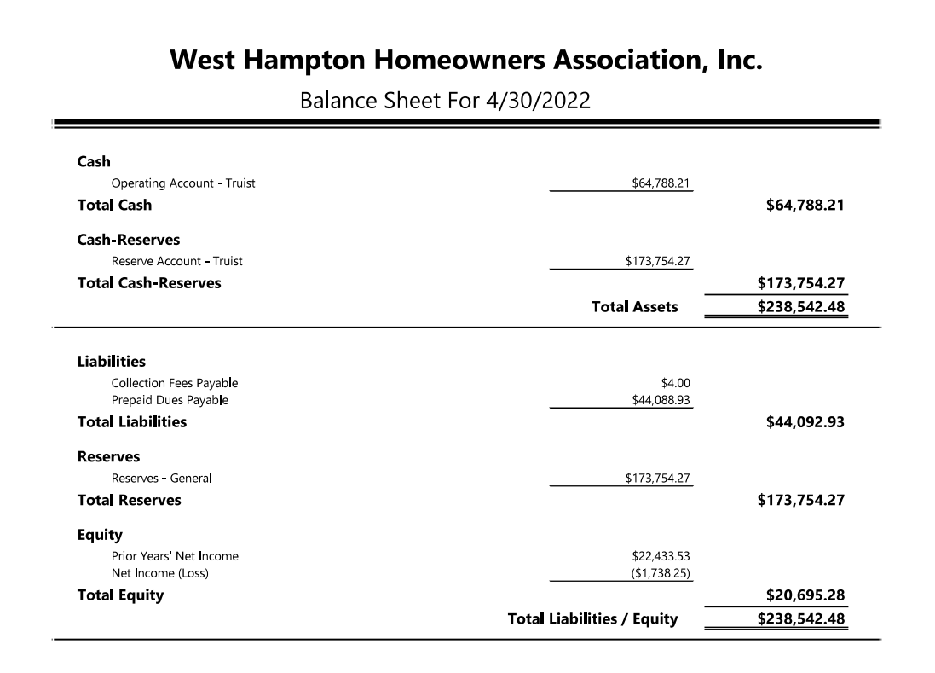

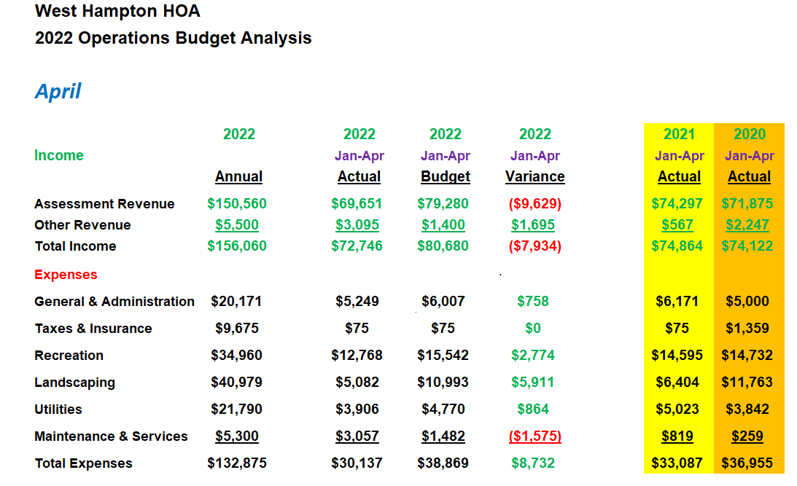
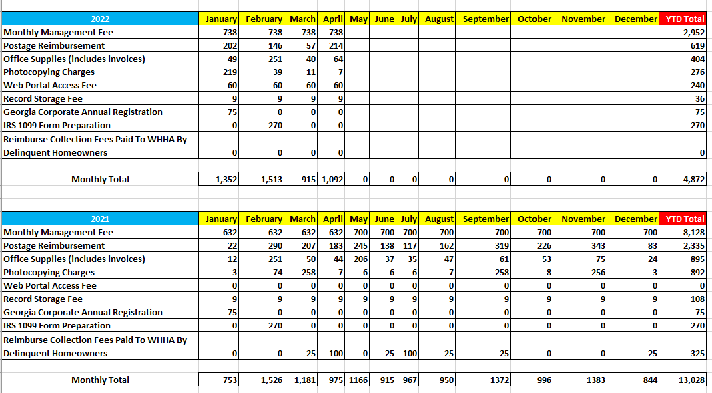

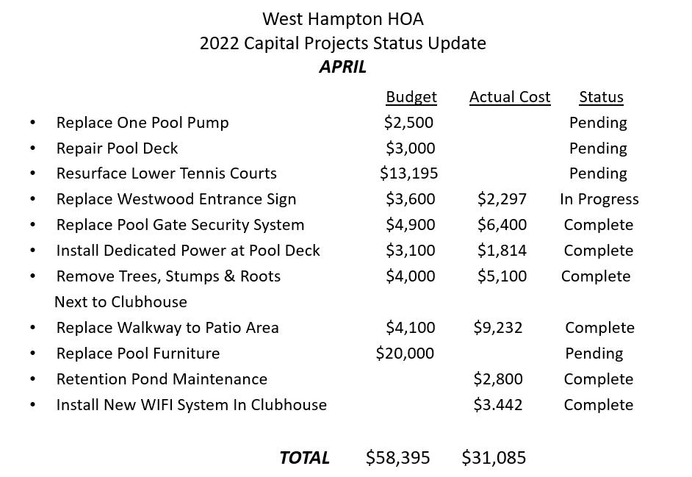

Tennis:
Spring is here and time to hit the courts. The mens Alta team is wrapping up another successful season and though we did not make the playoffs we had a winning record and a lot of fun doing it. I will submit the money collected from dues to Mr. Rooks in the next few weeks. We also have made a decision on the court resurfacing project and have elected to go with a company called Court Makers. They will be performing the work in June or July along with replacing the nets and most of the benches. I am very excited to finally get this on the books and know our tennis facilities will look great once completed. I want to thank the board for approval on this project and hope to see the the courts busy this Spring and Summer. With 4 new tennis courts playing shouldn’t be a problem but courts can be reserved thru Reservemycourt.com if ever needed.
Sincerely,
Jamey Linard.

