WHHOA Board Meeting Minutes
November 13, 7:00 PM
In Person at Clubhouse & Via Zoom Video Conference
Board Member Attendees: Steve Ryan, president; Bill Logan, vice-president; Patricia Ryan, Secretary; Finis McCarver, Director
Absent: Jeff Rooks, excused
Committee Member Attendees: Steve Milby
Community member attendees: Josh Orton

- Call meeting to order/Agenda overview

- Public Comment:

A concern was raised regarding communication within West Hampton. For instance, no emails were received regarding tonight’s meeting.
- Patty Ryan replied that the meeting notice and agenda for tonight’s meeting was sent to the webmaster too late in the week for timely posting. In the future, this information will be emailed earlier in the week.
- Unless association members have submitted their email addresses to the webmaster or Vantaca, neighborhood information is often not received.
- Not everyone is a member of the WH Neighbors – Unofficial Facebook page. While ‘unofficial’, pertinent neighborhood information is often shared on this site.
- The quarterly newsletter is now being sent to most residents with email, and hand delivered to those who do not have email but wish to receive the newsletter.
The subject of encouraging association members to help with committees or join the board of directors was introduced.
- The board has used the newsletter to solicit volunteers, personally asked people to help, and sent emails. The board is open to ideas that would encourage people to sign up.

- Consent Calendar
- Approval of previous minutes- Minutes of the October 10, 2022, board meeting were approved unanimously by board members present.
- Financial Report-Jeff Rooks. See report below (Report read at the board meeting by Steve Ryan, in Jeff’s absence.)

- Committee Reports

- Pool- Vacant
- Welcome –Whitney Meyers chair. No report
- Landscape- Bill Logan chair. See report below
- ACC-Bill Logan chair. See report below
- Tennis- Jamey Linard chair.
- Social-Debbie Ladin chair. See report below
- Clubhouse- Steve Ryan chair. See report below

- Old Business
  - Someone is needed to chair the Swimming Pool committee. The board feels that the options are:
    - The pool will remain closed until a committee is formed
    - The board will hire an outside company to run the pool at an unknown cost. This option is being researched.
- New Business
- Use of clubhouse for financial gain
  - Per Article 3 of the Articles of Incorporation, no Common Area of the WH subdivision may be used for personal financial gain. Specifically, inviting non-residents to participate in sales of any kind, paying outside sources for lessons, speaking, etc. is prohibited. Common areas include the clubhouse, swimming pool, tennis courts, or lawn areas. However, WH Association members MAY hire instructors for family and personal enrichment or for the benefit of other WH association members.
  - The board president was asked to contact our legal counsel for his interpretation of the Articles of Incorporation.

- Nominations for upcoming annual elections for the board of directors’ deadline 11/15/22
  - To date, there are 6 (six) people who will seek a board position.
- Annual meeting & election.
  - The Annual Board meeting and election will be held TUESDAY, JANUARY 24, 2023
- Status of water on the pool howe floor and gameplan going forward
  - Water continues to appear on the floor of the pool pump house, but the source continues to elude us. Water makeup to the pump house had been isolated so there is no possible contribution from that source. Nautix personnel have inspected all of the equipment in the pump room and can find no source of leakage of any component and it is not happening during backwash of the filters.
  - We have had an external inspection performed by a landscape architect with a specialty in hydrology. He pointed out that the ground level on the back side of the pool house has risen over the years to where it is above the floor level of the pool house. This allows water coming down the hill to saturate the soil along the pool house and seep in along the sill for the wall. He stated that this saturation can be from rain or any source of water from up on the hill like runoff from plant, grass watering and could show up days after the wetting takes place up above. He recommends that the area around the pool house be dug down to well below floor level and that it be backfilled with non-decorative rock to allow water to naturally drain off to the sewer drain located in the yard area behind the pool. He will submit an estimate in the next few weeks. This will be hand dug and not machine dug.

- Re-slinging of pool chairs in November – additional furniture needed
- Status of repairs to clubhouse window/ceiling
  - Included in the Clubhouse report below
- Recent upgrades to clubhouse furnishings – new table and chairs
  - Many thanks to Brenda Ray! More information is in Clubhouse report below.

- Meeting adjourned at 8:15 pm.

- The next Board meeting will be December 12, 2022

- Minutes written by Patricia Ryan

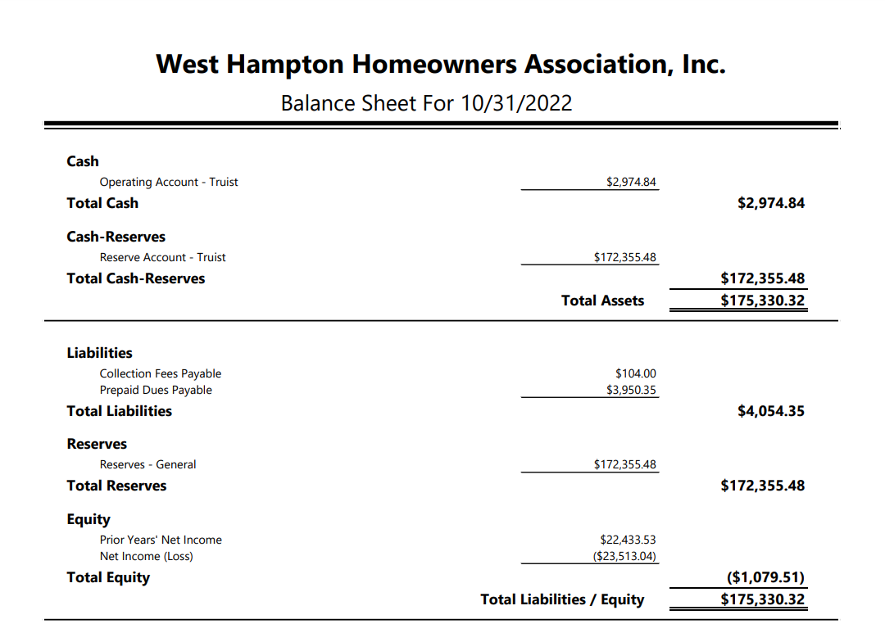
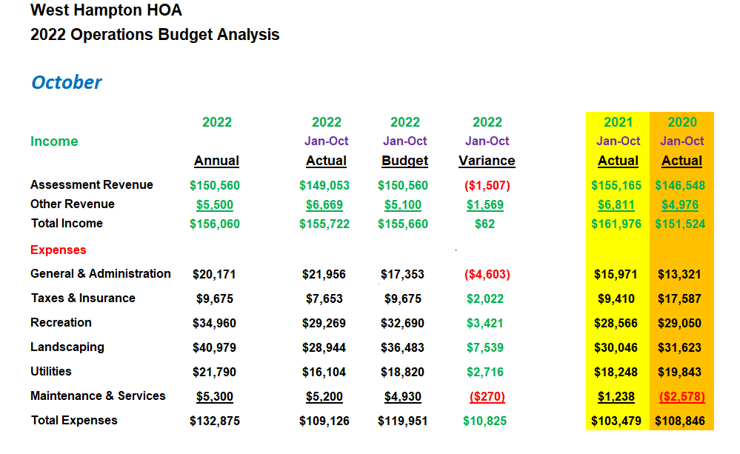
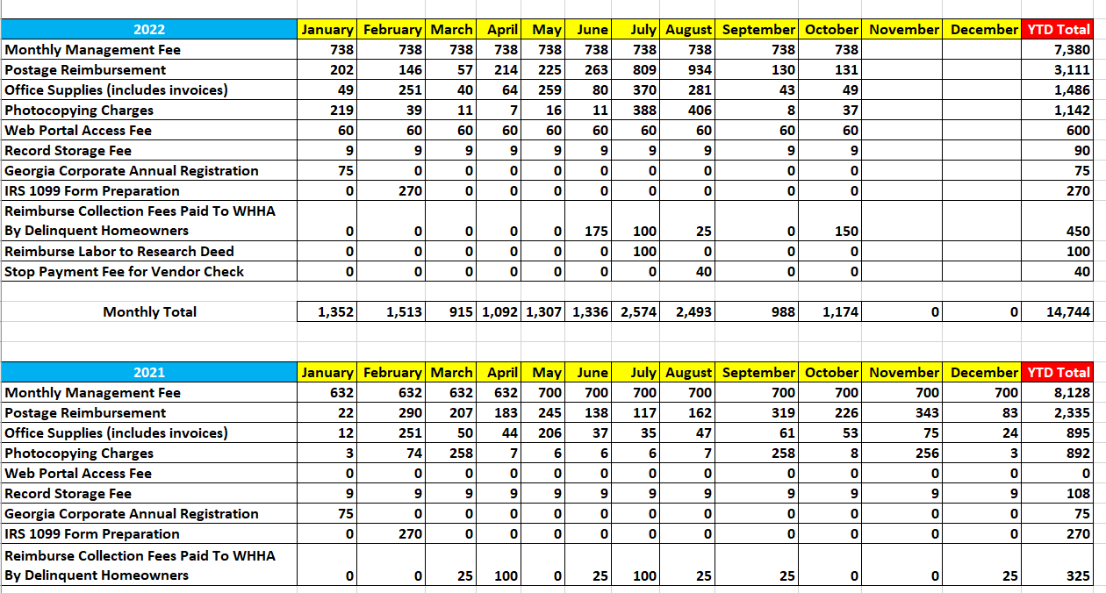

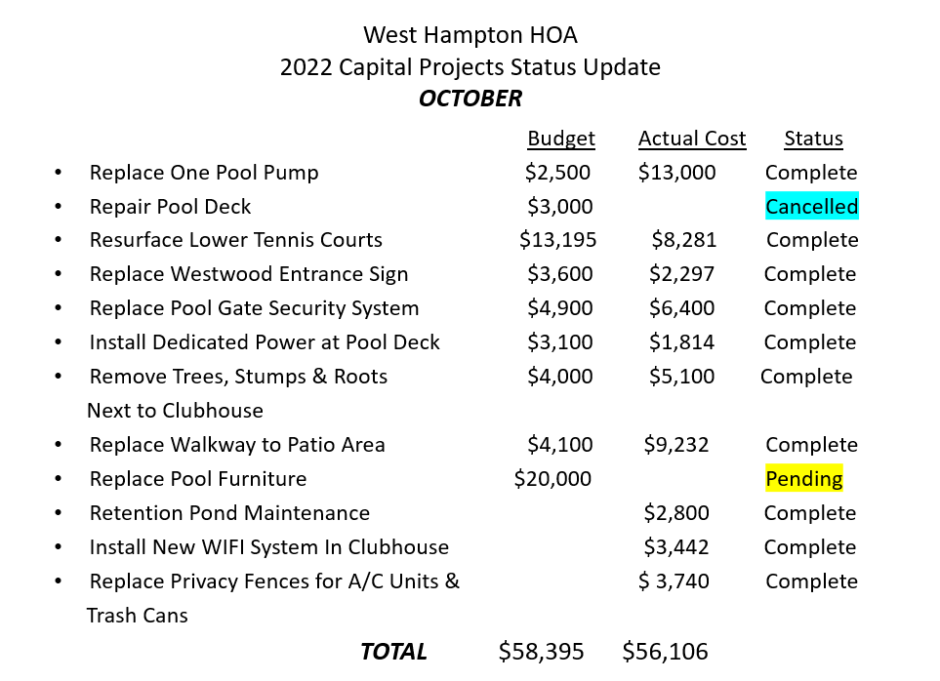

Clubhouse
- The Parker Young construction contract has been signed for repairs to the clubhouse window and ceiling area over the stairs to the lower level. We are waiting for a schedule date but expect the work to be completed by the end of the year.

- Brenda Ray has been busy with updating the clubhouse and adding some much-needed accents and decorative items. The old side tables & coffee table have been refinished instead of buying new, saving us hundreds of dollars through repurposing. Additionally, she found and negotiated for a new meeting table and six chairs for the clubhouse. We will be looking to continue upgrading the clubhouse a little at a time in 2023.
Stephen Ryan,
Clubhouse Committee Chair
westhamptonclubhouse@gmail.com
Tennis
- It’s been a busy month on the courts with both the women and men’s team finishing up their Alta seasons. I’m happy to say the men’s team has made the playoffs and have even won their first-round playoff match. I have collected the dues from both teams and will submit the checks to Mr. Rooks.
This month I also reached out to two tennis court companies that we have worked with in the past for estimates on pickle ball courts. Painting pickle ball lines on the existing courts is the most economical way to go. Talbot tennis would charge around 350 per court to do so and is the cheapest. Courts makers stated 850 per court. Making individual courts specially for pickle ball with nets is quite costly and would be roughly 10 grand to do. I will leave it up to the board to determine which way the neighborhood wants to go just let me know. As always see you at the courts,
Jamey Linard…
- The board will ask Jamey to provide formal bids for creation of Pickle Ball courts.
- The board will also ask Jamey if the creation of Pickle Ball courts on the current tennis courts will impact tennis league play.
Landscape
- Tree will be planted next spring to replace the dead maple removed from the large lawn area by the clubhouse parking lot.
- Plants have replaced the 3 trees that were removed next to the clubhouse.
- Pampas grass will be planted in the open space where trees were removed behind pool pump house
- Larry & Karen Smith donated 6 large Day Lily plants. They will be planted at the Due West entrance and in the pool area. Many thanks to Larry & Karen!

ACC
- It appears that inspections by Heritage have been hit and miss. They are missing some obvious violations while sending violation notices for relatively minor occurrences. Several homeowners have written response letters to Heritage and have not received answers.
- Rebecca Plokhoy (Heritage) has encouraged the WH board to sit down with her and the assigned inspector to review our needs. The board is eager to do this but, to avoid future confusion, wants to wait until upcoming changes to the Architectural policies are in place.
- The board wondered if the inspector is abiding by regulations specific to WH, as some of the violations do not appear in our documents.
- Finis McCarver suggested that the ACC develop a prioritized list for inspectors to utilize as they drive through the neighborhood. This idea was well received.
- Until the issue of violation notices is resolved, it was suggested that prior to mailing residents, Heritage email inspection reports to ACC committee members for review and comment.
- The ACC will compose a letter for Heritage to send to a resident regarding completion of front steps.
Social
- Breakfast with Santa Saturday, December 3 at 9:30 am in the clubhouse. Help is needed to decorate the clubhouse for Santa on Tuesday evening, November 29 at 7:00 pm.
- Chili and Rib cookoff has been cancelled. Will be rescheduled after the start of the new year.
Pool
- We continue to run with pool uncovered as we determine where the leaks are. It now appears the rate of lowering level has almost stopped indicating to us that the leaks are most likely in the skimmer boxes. These repairs will be made before we restore the pool level to normal. We may not do the refill until the spring

- Re-slinging of the pool chairs is due to start this month and will finish in December.

- We are still in need of someone to step up to organize and chair the Pool Committee to ensure the pool is ready for next summer. Time is running out to get the things done that need to be completed before opening the pool in April-May. The board relies on community support to keep all of our needed committees staffed and functioning. Without them we cannot provide the necessary services without adding great expense to the homeowners. We have only two options for the pool. Either we have our own Pool committee (which is non-existent right now) manage the pool or we hire an outside organization to fully manage the pool. The members of the board will not assume this responsibility. Without a pool committee and someone to chair it we will not open the pool in the spring.

Stephen Ryan,
Acting Pool Committee Chair
westhamptonclubhouse@gmail.com

