WHHOA Board Meeting Minutes
July 11, 2022, 7:00 PM
In Person at Clubhouse & Via Zoom Video Conference
Board Member Attendees: Steve Ryan, president; Jeff Rooks, Treasurer, Patricia Ryan, Secretary;
Absent: Bill Logan, Vice President; Finis McCarver, Director
Committee Member Attendees: Whitney Meyers, Steve Milby, Dorothy Minter, Jamey Linard
Community member attendees: 3

- Call meeting to order/Agenda overview
  - Verified that a quorum was present

- Public Comment:

  - Residents Gil Moor and Michael Deppa of Cobbs Farm Trl. showed a photo of how the developer of Jackson Heights has encroached very close to their properties. They asked if the board had suggestions about who to contact at the county level. They had already reached out to Commissioner Keli Gambrill and the Planning & Zoning dept, and each told them to contact the other. The board told them that the men had done what the board would have advised, and that the board would continue to look for ways to get answers.
  - A neighbor asked for some clarification about the proposed POA amendment. The board provided an explanation and encouraged her to attend one of the upcoming information meetings.
  - It was noted that excessive algae was in the swimming pool. Dorothy will speak with Nautix.

- Consent Calendar
- Approval of previous minutes- Minutes of the June 2022 board meeting were approved unanimously by those board members present.

- Financial Report-Jeff Rooks. See report below

- Committee Reports

- Pool-Dorothy Minter chair.
- Welcome –Whitney Meyer chair.
- Landscape- Bill Logan chair. See report below
- ACC-Bill Logan chair.
- Tennis- Jamey Linard chair. Some debris was left on the tennis courts by people lighting fireworks on July 4. This debris seems to have been blown in during the storm and not from being set off on the courts. The paper that was ‘baked’ on was difficult to clean but it doesn’t appear that the courts were damaged. Also, a few people have been skateboarding on the courts. Locks will be placed on the rear gates of the courts.

- Social-Debbie Ladin chair. No Report for July
- Clubhouse- Steve Ryan chair; Brenda Ray. See report below
- Playground: The board is looking for an affordable means to erect a new playset. It was suggested that we research playsets that could be purchased, then assembled by neighbors.
- Home Rental Limitations: Steve Milby chair. The committee is ready for the next step in the rental restriction process. Steve will prepare a Power Point presentation for the August POA information meetings.

- Old Business
- A. Odor in lower clubhouse – Update - Terminix was hired to set traps and remove wildlife on 7/1/22. There will be weekly trap inspections for 3 weeks or until no additional wildlife is trapped. Steve Ryan placed odor absorbent material in the clubhouse basement and the odor has dissipated. In addition, the large hole from under the deck to the basement where wildlife is likely entering the building has been covered with heavy metal screen to prevent wildlife from entering.
- Playground equipment- Update – Steve Ryan mended the monkey bars by replacing old lag bolts with carriage bolts and tightening as many joints as possible. The monkey bars are no nearly as wobbly but there is still movement in the structure. The structure is old. The wood has dried out and shrunk considerably, creating for looser than desired joints. The structure is sound and safe to play on but really needs to be replaced in the next 12 to 18 months.
- Pool: request made in June for small area to house bathroom soap and cleaning products for lower-level bathrooms. Update – The purchase of a cabinet has been approved by the board, but Dorothy reported that lifeguards have been present enough to take care of the bathrooms. At this time, the cabinet is not needed.
- Pool: shed floods whenever it rains. Dorothy was to ask Nautix to check if backwash system is working properly. Update 7/1/22 – Steve Ryan spoke to the Nautix technician while doing backwashes and verified that the water is not coming from the backwash process. This leaves only water from rain intrusion as the cause. Need to discuss trenching and rerouting options with the landscaper.
- Pool area needs exterminator to treat for ants. Update – ProCare was out to the pool and clubhouse area on 6/15/22 and heavily treated the pool and playground areas with Niban ant baits. The technician spread approximately 6 lbs of Niban in the area around the pool and play area.
- Pool: Dorothy to call security company for pricing on alarm for pool gate.
- Large, unauthorized party held at pool. Update – Steve Ryan discussed the violation of our amenity’s rules with the persons responsible for holding the large event at the pool. It was made clear that this cannot happen in the future and should not have happened at all. The persons responsible agreed that this will never happen again from their end and the matter was resolved.
- Clubhouse Reservations for POA Information Meetings. – Update - The clubhouse has been reserved for Wednesday August 10, 2022 for a 7 PM Meeting and Saturday August 13, 2022 for a 1 PM meeting.

- New Business
- Property Owners’ Association Act “Case for Action” mailing update: All association members should have received the Case for Action letters

- Status of mass mailing of the proposed amendment and cover letter: On July 11, Heritage Management company received the packet from the board containing a cover letter, final draft Amendment, Amendment explanation document, and a Consent form. Heritage will mail the packet to all WH homeowners.

- Posting of “Question and Answers” regarding the transition to a POA on the West Hampton Web Site. Q & A’s have been posted to MyWestHampton.com

- Posting of the Proposed Amendment on the West Hampton Website. Submitted to Webmaster for posting.

- Status of maintenance concerns for 3557 W. Hampton and 350 Battle Woods Trl. The board had difficulty locating contact information of the corporate owners of these properties, finding that both are out-of-state. The owners of 3557 WH responded quickly to our request for upkeep of the property. We were assured by the owner of 350 Battle Woods that a work order has been filed for removal of the trees that were struck by lightening during the storm in early July.
- Clubhouse Reservations for POA Information Meetings. Dates for the meetings have been scheduled for Wednesday, August 10 at 7:00 pm and Saturday, August 13 at 1:00 pm.

- Swimming Pool Closing– The board decided to monitor the weather to determine the date to close the pool for the season.

- 2023 Budget items – The board has developed a list of items to be purchased or completed in 2023. We will prioritize these items and send to Heritage Management in a timely manner.

- Meeting adjourned at 8:25 pm.
- The next Board meeting will be Monday, August 8, 2022

- Minutes written by Patricia Ryan

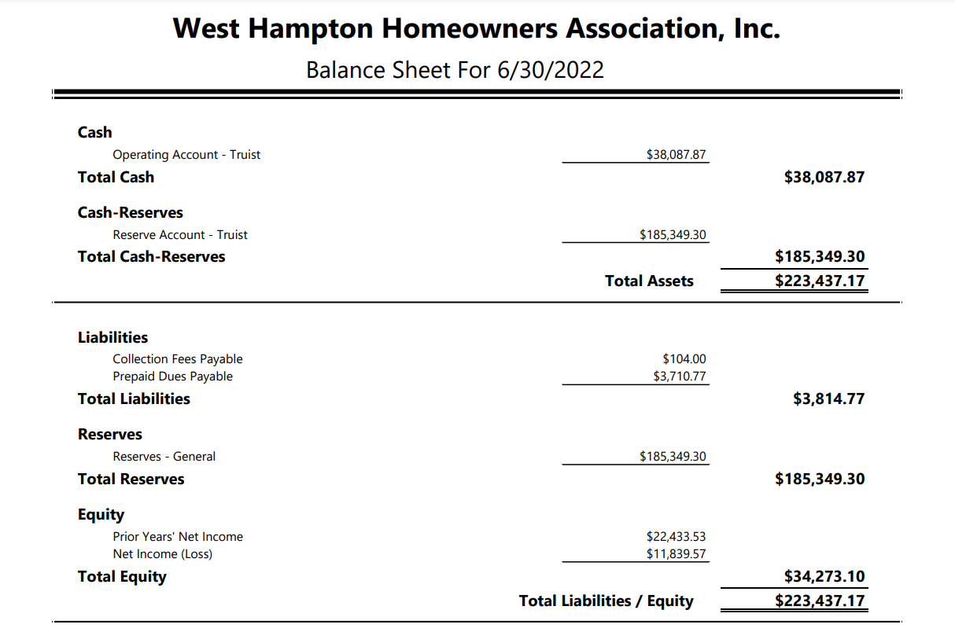
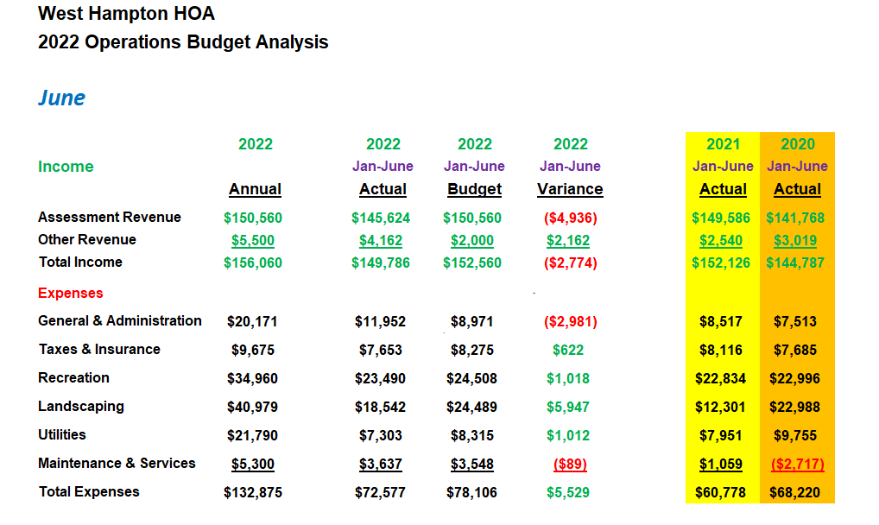

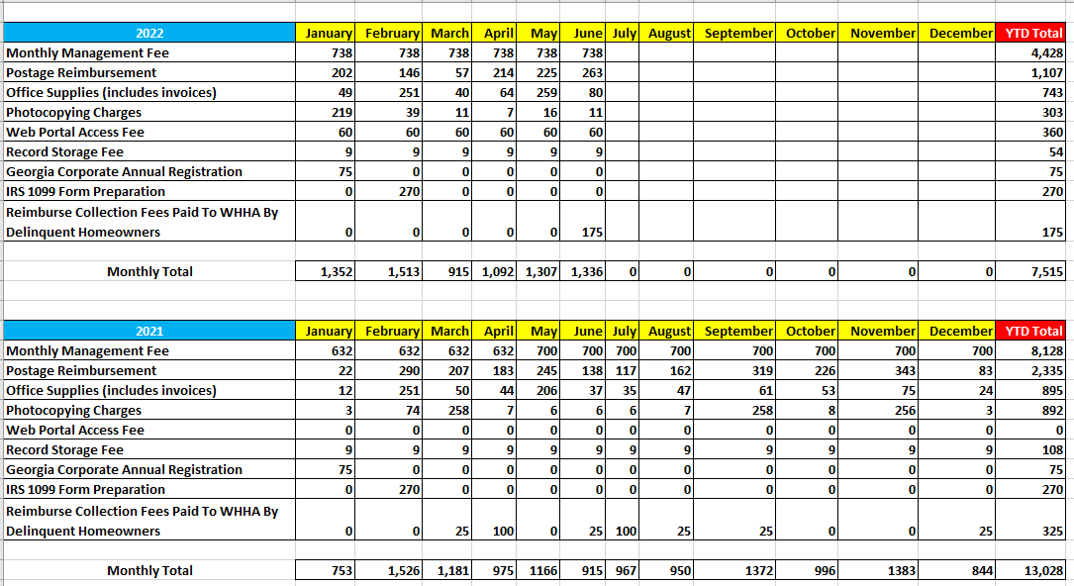
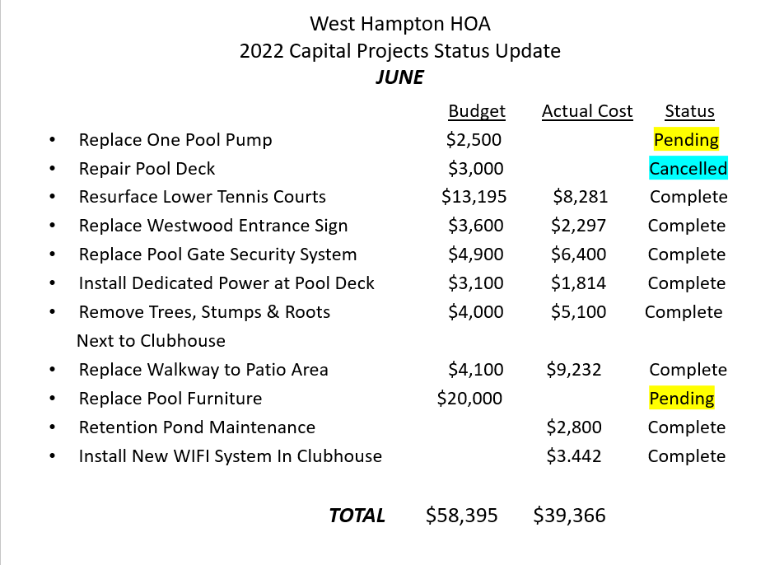

Clubhouse
- Brenda Ray has kindly agreed to join me on the Clubhouse Committee. She will be a huge asset with managing the clubhouse, activities scheduling and access, and maintenance demands. We plan to slowly begin some upgrades and improvements for the facility as budget allows. It has been suggested by the board Secretary that we screen in the back deck area to keep birds and bugs out and actually make this an inviting and usable place for events. The furnishings in the clubhouse are quite old (very outdated) and need to be replaced over time so we will be looking at ways we can accomplish this with minimal cost. Thank you, Brenda, for stepping up.

- Sprinkalawn replaced the backflow preventer valve at the Burn Hickory entrance on 6/16/22. It was under warranty so there was no billing for the replacement. The valve was tested and was satisfactory. Statement of compliance was received. Cost of retest was $90.

- Received the estimate to rebuild the enclosures for the trash bins and A/C units and the board approved the expenditure since the structures were falling apart. Bk Rennovation 1 completed the work on 6/28/22. Additionally, the crawl space hole in the clubhouse basement has been closed with metal screening to keep wildlife out of the building. Total cost $3,740.

- The playground monkey bars have been reinforced by replacing lag screws with carriage bolts to stiffen the structure and repair broken supports. The structure is sturdier but this is a short-term fix. The bolting used to build the structure is beginning to rust and cannot be replaced. The wood structure is not rotting but the wood is very dry and needs to be replaced or taken down in the next 12 to 18 months. We need a solution in the next year or so. Additionally, the mounting brackets for the swings have been tightened to compensate for wood shrinkage as it has aged. Cost of materials $80.

- Terminix was contracted for wildlife removal in the clubhouse and have place traps in the ceiling areas and around the back storage areas in the clubhouse. They will be checking the traps once a week for three weeks or until they are no longer trapping animals. Traps were set 6/29/22. First inspection on 7/5/22 found no animals trapped. Cost $500 for the initial trap placement and $100 per week for 3 weeks for trap inspections and animal removal.

- I have purchased a new Canister Vacuum Cleaner for the clubhouse. The selection was based on what Kristie Duncan felt would best suit her needs. The expense was approved by the board before the purchase. $250.

Stephen Ryan,
Clubhouse Committee Chair
westhamptonclubhouse@gmail.com

Architectural Control Committee: request for June 2022 , None (no formal request)
Landscape
Spoke with Matt Aultman on the boards decision to up the monthly payment to help cover the rising inflation rate. I told him we had decided to go back to day one with his company start date and he should see this with his next invoice. (Jeff?)
Matt also recommended a landscape design person for the area above the new sidewalk. I will be in touch with that company hopefully in the next week or so. Also my contact at Lowes has a recommendation which I will reach also reach out to.
Going forward looking to add plants and shrubs around CH that are returning vegetation . The area overall seems to be filling in for the future growth.
Irrigation
Spoke with Matt ( landscaper) about brown area in large grass area to the south of CH parking area about a possible broken head. He will check it out on next grooming.
* We need to insert a treated 2x 4 over irrigation tube in the CH side walk where Sprinkalawn ran a new line to the large maple tree.
Just a reminder
I will be out the 25th of July on - until recovery.
I will have Josh Orten cover for me at that time and will have him contact the board. I will also let Matt at Property Lines Landscape know about my situation and contacts if any questions.
Tennis
I hope everyone is enjoying their summer. I am pleased to say that the bottom 2 tennis courts have been resurfaced and are ready for play. We now have 4 beautiful tennis courts that the community can be proud of for years to come. Along with the courts we have brand new benches and nets all the way around. I play a lot of tennis and in my opinion, we now have some of the nicest courts in all of Cobb county. Nothing else to report at this time and I hope to see you at the courts!
Sincerely,
Jamey Linard…

Swimming Pool
Lifeguards – I continue to update the neighborhood on FB when we will be without lifeguard coverage.
Last day of daily lifeguard coverage will be 7/31. Then we will go to coverage only on weekends until Labor Day. From Labor Day to when the pool closes, it will be only swim at your own risk.
We need to decide when the pool should close for the season. I suggest September 5th (Labor Day).
Swim Team ended on June 30th with the banquet. We had 98 swimmers, 40 of which were non-resident. Swim team owes the HOA $1200
Upcoming – finalization of pool furniture and quotes/estimates for pool resurfacing for 2023 • Issues – take care of the ongoing algae issues on the bottom of the pool from Nauti

