WHHOA Board Meeting Minutes
June 13, 2022, 7:00 PM
In Person at Clubhouse & Via Zoom Video Conference*
- Difficulty with the new Zoom account prevented video conferencing at this meeting.
Board Member Attendees: Steve Ryan, president; Bill Logan, Vice President; Jeff Rooks, Treasurer; Patricia Ryan, Secretary; Finis McCarver, Director
Absent: None
Committee Member Attendees: Whitney Meyers, Steve Milby, Dorothy Minter
Community member attendees: None

- Call meeting to order/Agenda overview

- Public Comment: No public comments

- Consent Calendar
- Approval of previous minutes- Minutes of the May 2022 board meeting were approved unanimously.

- Financial Report-Jeff Rooks. See report below

- Committee Reports

- Pool-Dorothy Minter chair.
- Welcome –Whitney Meyer chair.
- Landscape- Bill Logan chair. Report below
- ACC-Bill Logan chair.
- Tennis- Jamey Linard chair. Report below
- Social-Debbie Ladin chair. Report below
- Clubhouse- Steve Ryan chair. Report below
- Playground: Report below
- Home Rental Limitations: Steve Milby chair

- Old Business
No Old Business to discuss

- New Business
- Review, modify & adopt Fees and Fines Waiver Guidelines. Guidelines for waiving fees were developed, taking a variety of situations into account. The board unanimously voted to adopt the guidelines

- Review Bylaws Amendments passed in January 2019. The board received information that amendments to the bylaws were adopted by a vote of the association members present at the January 2019 annual meeting. However, because they were not disseminated to all the association members, they did not take effect. The current board was unaware of this situation. Heritage will mail the amendments to the homeowners before the end of this month, along with a cover letter explaining the circumstances. The amendments will take effect on the date of the mailing.

- Review existing Covenants with amendments attached. When amendments to bylaws and covenants are passed, they are placed at the front of the original document and reference the bylaw/covenant amended. Heritage has been asked to place the newly adopted amendments in this manner on their website.

- Initiate discussion to outline a ‘Case for Action’ document to use as framework for POA discussion.

  - The board proposed to initiate a document to present to the association members that outlines the benefits of changing from a Homeowners’ Association to a Property Owners’ association. The board will hold several information meetings to provide everyone the opportunity to hear information and ask questions. In order to amend the covenants under the POA Act, at least two-thirds (2/3) of the owners who have a right to vote, must vote in favor of the amendment.
  - The board asked if anyone knows of a community that has changed from an HOA to POA in the area. Steve Milby stated that he knows of a person in this situation that may be willing to speak with our board and answer questions.
  - Steve Milby will ask the rest of the Rental Restrictions committee to attend meetings to offer their insight and become familiar with the POA act.
  - The BOD will hold a special meeting to further discuss how to proceed with presenting the POA concept.
  - Steve Ryan will develop a ‘Case for Action’.

- Discussion of Q&A from Mr. Rome regarding the proposed scope and impact of the POA amendments
  - Regarding implementation of liens for nonpayment of annual dues, Rome and Assoc. recommended that our association not allow more than 120 days before proceeding with the lien process. This is because once the attorney receives the request, it will take approximately another 120 days to take effect. The difficulty

is that if a homeowner sells outside of a Mortgage company (i.e. to a cash buyer), Heritage Management Co. won’t necessarily receive information on the new owners.
  - A home in the neighborhood that is owned by a corporation is in arrears for dues. Our attorney has recommended that we complete a title search to locate the address of record for the owner and mail a past due notice.

- Discussion regarding a mailing now or in the near future, to solicit interest in participation on the board. The board is concerned that there will not be enough people to fill the required board positions in 2023. Per the amended bylaws, two persons from the same home may not serve on the board at the same time. This directly impacts the current board. At this time, we may maintain the status quo until the annual meeting in January 2023. Committees are in urgent need of members to help with projects and events that impact us all.

- Discuss potential projects that need to be done in 2023. The board was asked by Heritage to submit budget estimates for 2023.

- Graduation Banner at Due West Entrance. Invoice has not been submitted for payment. Patty will request that the invoice be turned in.

- Wildlife in clubhouse. A strong odor in the downstairs bathroom areas has been attributed to at least one dead rat. Terminix was called to provide an estimate of the cost of providing services to rid us of future rodent infestation. In full disclosure, the Terminix representative is a relative of the board president and secretary.

- Audit Report: WHHOA receive the audit report for the years 2020 and 2021. All was determined to be in order with our accounts. The auditors noted that West Hampton does not have a ‘reserve plan’ for large projects that will need to be done over time. These would include items such as asset review for replacement schedules, roofing replacement, HVAC lifetime replacement projections, appliance replacement projections, water heater replacement projections, pool pump life and replacement schedules, furniture replacement and other potential demands on budget reserves for future years. It is not a requirement but an audit finding in the report that West Hampton does not have that plan in writing.

- Meeting adjourned at 9:10 pm.
- The next Board meeting will be Monday, July 9, 202
- Minutes written by Patricia Ryan

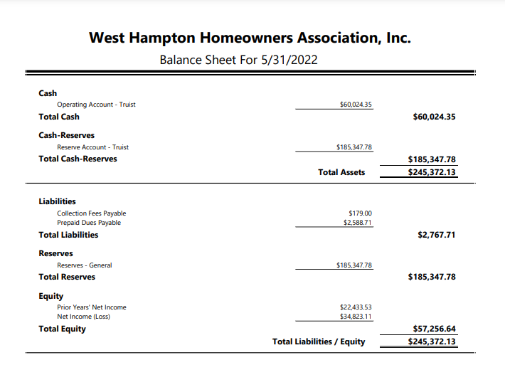

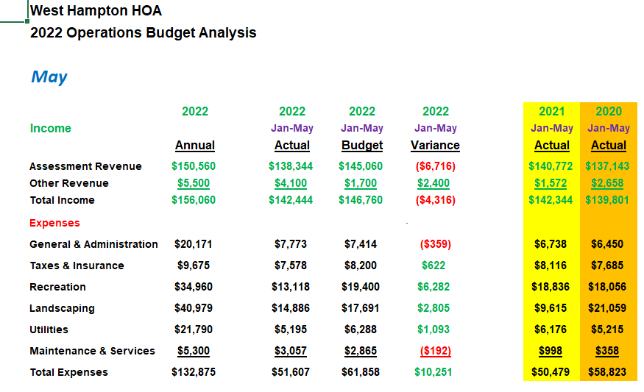
---------------------------------------------------------------------------------------------------------------------------------
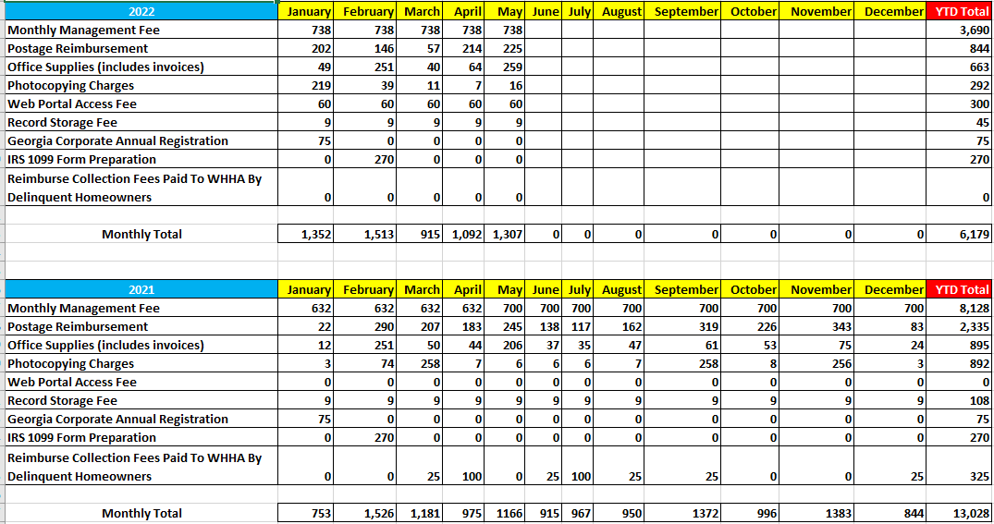

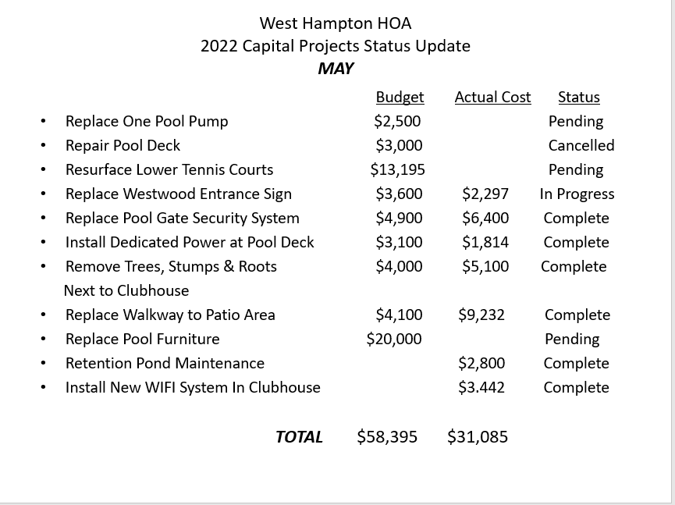

Landscape:
Property Lines, the company that provides the landscaping service for WH has been doing a nice job. In speaking with the owner, it was discovered that, because WH is a new customer, the company has not increased our fees as it has with other customers. This young company has been having difficulty maintaining employees and has been impacted by rising fuel costs. In fairness, the board voted to offer Property Line an increase in the fee to be more in line with neighborhoods like ours.
There is a hole along the side of the new walkway that was not refilled by workers, as well as exposed black hose.
ACC:
Five requests for home improvements were submitted and approved.
A statement was made at the board meeting that a tree company has approached some neighbors, telling them that some of their trees are diseased. Then, this company solicits the job of cutting the trees. One neighbor was approached but found that their trees were fine. In response, the committee said that It is difficult to deny permission to cut trees because residents have a variety of reasons why it is necessary to remove them.
Clubhouse:
- Following the flush of the irrigation backflow preventer valve at the Burnt Hickory Entrance, Psycho Plumbing tested the valve and again it failed. Sprinkalawn was called on 6/1/22 to replace the backflow preventer valve. Once replaced we will coordinate with Jennifer Dexter at Psycho Plumbing for the post installation retest. (770-614-9032) This valve must be replaced and tested before June 30, 2022 or closed and isolated to meet Cobb County code requirements.
  - Backflow prevention assembly(s) within the Cobb County Water System are required to be tested on a regular basis. Our records indicate that backflow assembly(s) under your control have failed this years' annual test and must be repaired or replaced and retested.
Type Size Make Model SN Due
DC 1" WILKINS 350 AJA4586 4/30/2022
In Utility Box Right Side Burnt Hickory Entrance
  - In order to comply with Chapter 122, Section 121, of the Official Code of Cobb County. A certified and licensed tester must test the listed backflow prevention assembly(s) annually. Accordingly, you are required to have the above assembly(s) tested and a completed inspection reports returned to our office within 30 days from the date of this letter. If you have previously sent in reports for this year, please disregard this notice.

- A new sign was purchased for installation on the pool gate to ensure homeowners understand the pool rules regarding minor children when there is no Lifeguard on duty. This was done in response to the inconsistent availability of lifeguards this summer.

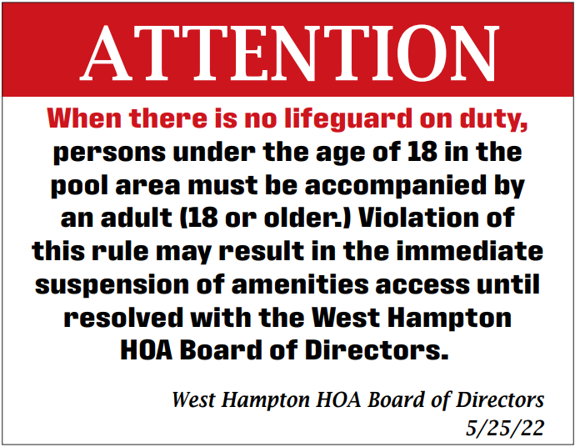

- Sprinklers were reinstalled along the new sidewalk, corrected a few pieces that got damaged from the staking done during the concrete work and capped an unused portion of sprinkler line. This completes the walkway replacement. Cost for reinstall and repairs was $391.95.

Stephen Ryan,
Clubhouse Committee Chair
westhamptonclubhouse@gmail.com

Pool:
One broken pump was replaced with a 5 HP redundant pump.
Nautix told Dorothy that they will give her updates on lifeguard availability every 2 weeks. So far, we’ve been without lifeguards for two whole days and three ½ days. WH will be reimbursed for periods when lifeguard service is unavailable.
Dorothy requested a small shelf or cabinet for keeping some supplies for cleaning bathrooms and pool area. The treasurer gave her Costco debit cards that the association has for such purchases.
After several years of use, the centerline of the pool is in need of replacement.
The pool shed has damage to the back wall caused by flooding and standing water. The BOD questioned whether the water damage was the result of rain or improper flow of the pool backwash system. Dorothy will ask Nautix to have someone, possibly lifeguards go to the back of the shed during backwashing to observe.
The next Shark home meet is tomorrow, June 14. There won’t be any food trucks. Our second home meet is on June 28th and the third will take place on July 6th.
Dorothy will be out of town from June 15 – 29.
In case it’s needed, our webmaster has access to the pool security system.
Pool area needs the exterminator (ProCare) to treat the pool area for ants.
An alarm to sound when the gate is left open will require an addition to the current system. Association members propping open the gate continues to be a problem. Dorothy will find out how much extra an alarm will cost.
The board asks all association members to review the pool rules. Five guests are permitted for each residence. This is not per person in the household. Dorothy received several complaints about a very large party in the pool area on Sunday, June 12th.
A lifeguard allowed a couple of friends be in the pool area. When told that this wasn’t allowed, the lifeguard immediately asked the friends to leave but they refused. These people were approached by a committee person and became verbally abusive. They were told to leave the WH pool and clubhouse area before police were called. At that point, they left. The incident was reported to Nautix
Welcome Committee:
No homes were put up for sale during May and no homes were sold.

Tennis

It’s that time again when the kids say goodbye to another school year and start the season of fun. The courts will see plenty of action in the next few months as I have already seen an up tick in the amount of people playing tennis. Both adults and children are getting out there and enjoying the wonderful game of tennis and it’s great to see. I have recently touched base with Court Makers and they plan to start construction on the bottom two courts in late June though the project is weather dependent. The project should last approximately 1 week. With 4 new courts we should have plenty of court time for anyone who wants to play. For those who chose, courts can also be scheduled on Reserve my court .com. Nets and benches have been purchased as well so soon our facilities should look wonderful. I wish all a wonderful summer and I’ll see you at the courts.
Jamey Linard…

Social Committee:
There are a few events coming up,
We are looking into movie night at the pool
End of year BBQ (not sure of the date yet)
Halloween
Chili/Rib cook off
Breakfast with Santa
Adult Christmas Party
Any help you could offer to help with these events would be greatly appreciated. Please contact Deb Ladin at: deborahm@ladinlaw.com
Playground:
The play structure needs to be stabilized with longer bolts. The board has contacted a carpenter to provide an estimate of the cost to do this.

