WHHOA Board of Directors
Steve Ryan, President
Steve Milby, Vice President
Jennifer Taylor, Secretary
Jeff Rooks, Treasurer
James Fudge, Director
Bill Logan, Director

MEETING AGENDA
7:00 p.m. June 12 ,2023 In Person and Via Zoom

I. Call to Order and Orders of the Day
II. Public Comment
III. Consent Calendar
- Approval of the April 10, 2023 West Hampton Homeowner Association (WHHOA) Board of Directors Meeting Minutes
IV. Financial Report
V. Committee Reports
- Pool/Swim (Steve Ryan)
2. Welcome (Patty Ryan)
3. Landscape Sprinklers (Bill Logan)
4. Architectural Control (Bill Logan)
5. Clubhouse (Steve Ryan)
6. Tennis (Jamey Linard)
7. Social (Deborah Ladin)
VI. Old Business Pool
- Lower Tennis Courts, making into pickleball courts (update)
Since Jamey was not at the meeting, this was not discussed
- Deck Work on Tennis Courts (an update will be provided)
Since Jamey was not at the meeting this was not discussed
VII. New Business
- Pine Beetles Infestation
The pines on the upper tennis courts are infested. Two of the pines are dead and one is being eaten by the pine beetles. West Cobb Tree Service came out and gave a quote of $2000 to cut the trees down and grinded. Steve Ryan made the motion to approve and the board agreed.
- Pool Resurfacing (presentation and bids discussion)
Gary Schweitzer presented the four bids for the pool resurfacing and went through each bid. Of the four bids, it was narrowed down to two by the board. Those two companies are EnviroDek Concrete Surfacing and Precision Pool Renovations. Gary is going to go back and get further clarification on items on the bids.
- Open Waiver Request (discuss and resolve)
This was tabled for discussion for a later date
- Board Succession Planning
Most of the board has put in notice that they are ready to move on and that a succession plan needs to be put in place for the upcoming year. If no one steps up, the management company would be in charge. Need to figure out a way to get residences involved and volunteer to sit on the board.
- Abatement Resolution (next steps and where do we go from here)
Paperwork is ready, just need to get signatures and have notarized.
- 2024 Capital Projects
Pool Deck -possibly start end of 2023 and finish in 2024
Playground
- Modifying Wavier Guidelines
This was tabled
VIII. Adjourn

Financial Reports:
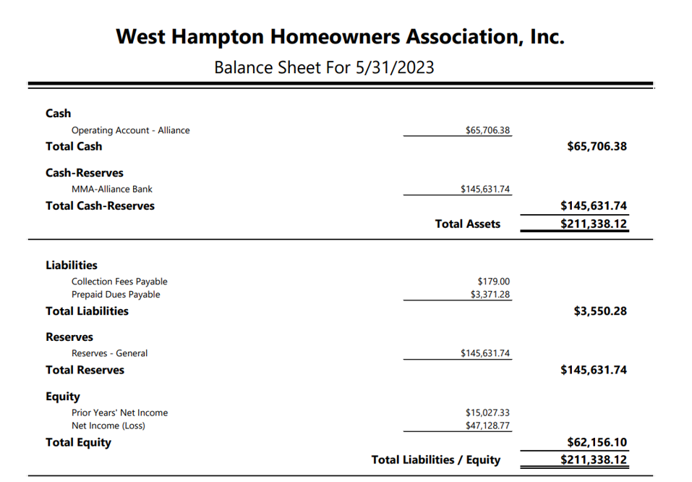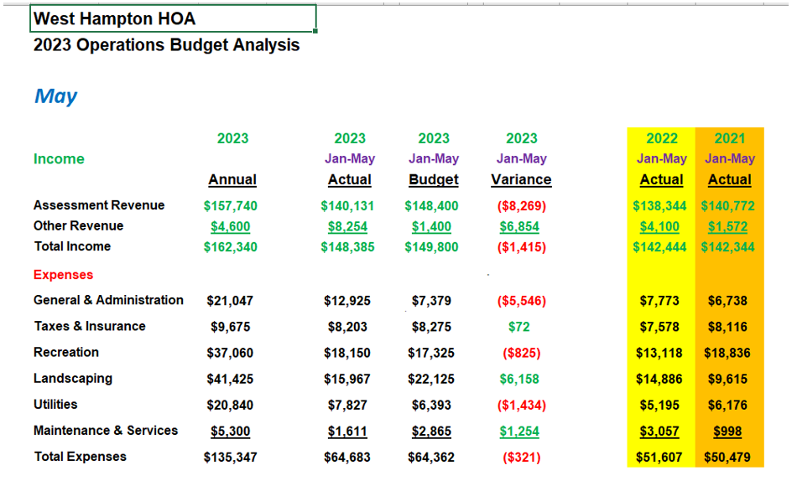
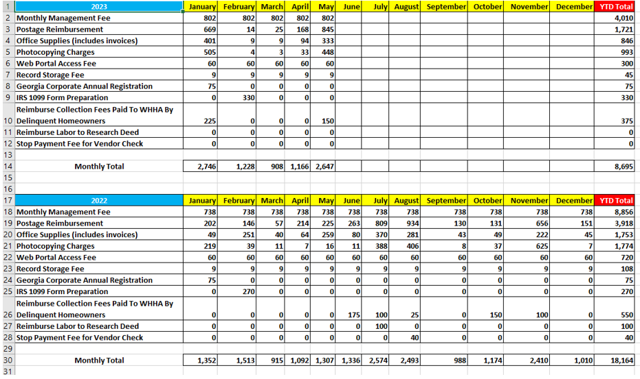
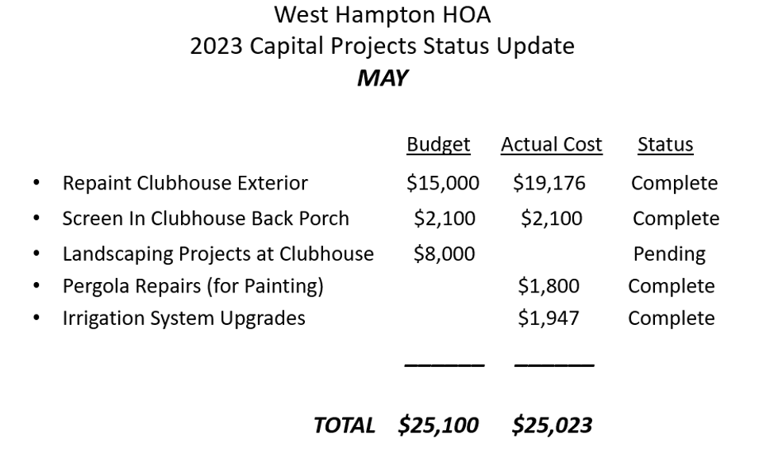

Committee Reports:

Pool Committee:

- Gary Schwitzer has been working with the pool committee to identify and obtain bids from several companies to repair and completely resurface the pool decking. If you use the pool, you are aware that there are many areas where cracking has occurred as well as concrete lifting from /tree roots. The trees causing the problem have been removed to prevent further degradation. Bids received so far will be presented and reviewed at the June 12 Board meeting. Gary will present the bids and the associated work scope for each at that meeting.

- Reminder that the pool closes at 11 PM. We have had a couple of instances were some of the teens were observed swimming past 11PM and were asked to leave. They were very cooperative and left the pool area when asked.

- The shark’s season is well underway and we are looking forward to the competition starting this month. There are 108 swimmers on the Sharks team this year, mostly younger kids. Approximately 60 of the 108 swimmers are from the West Hampton subdivision. This is an indication of the rejuvenation of West Hampton as more young families are moving into a great neighborhood.

- New Amenities rules postings for the pool area and the Tennis courts will be posted the week of June 12th. With the new guidance in our covenants, violations of posted rules can result in a $150 fine per incident and loss of amenities use privileges. Please know the rules. Follow the rules and help preserve our amenities and the safety of everyone.

Welcome Committee:

Homes sold: 3357 Bridle Run
3389 Bridle Run
Pending: 3524 W. Hampton Dr
3455 Horseback Trl

Clubhouse Committee:

- I have replaced the two broken security cameras, one at the clubhouse entrance and one at the pool gate. Additionally, I have added another camera at the pool to capture the Due West end of the pool area for safety and security concerns. Cost: $431.97 for the cameras plus $220 for installation and repair of wiring at the clubhouse which caused the camera failure.

- I purchased 100’ of hose for the new clubhouse hose bib to allow watering of plants and trees around the clubhouse and the new trees planted down near Carlyn court.

- Clubhouse rentals for April and May were strong with six rentals in April and nine in May. Looking to June and July we currently have one rental scheduled for June and two in July.

- I have received board approval to purchase a steam mop for cleaning the Clubhouse floors. I have not made the purchase yet but shopping around it appears the cost will be between $100 and $150.

- I purchased large (55gal) trash can liners ($56.39) and 6 additional large rolls of toilet paper for the downstairs bathrooms. $49.98
Tennis Committee

Summers here. Tennis courts have been packed with all sorts of people and I’m glad to see it. Kids and adults alike all having fun in the sun. It’s great to see the facilities getting use.

I have contacted Talbot Tennis again about striping the bottom courts for pickle ball and they have said they’ll get to it as soon as they can. We have also had tennis signs made up indicating times for play to help reduce noise concerns.

I would like to have some repairs made on the deck but still am unsure whether that has been approved. An estimate was submitted. I hope everyone enjoys their summer and as always, I’ll see you at the courts!!

Social Committee:

Last day of school ice cream by the pool was a success!!

I am currently looking for any volunteers to help out with scheduling movie night by the pool. Maybe one in June, July and August.

Also volunteers for a possible end of year (adult) party at the pool.

Anyone interested please text me. 678-361-9682

Swim

Swim team is in full swing. We had 108 swimmers registered. Our 1st home meet (last Tuesday) was rained out. I noticed complains on the unofficial FB page about parking during the meet and want to assure you that the “no parking on this side of street” signs are correctly placed and go all the way up West Hampton Drive to the 1st stop sign and go in front Westwood Drive all the way to Blair Place. In addition this year I have a parking attendant volunteer that monitors parking from 4:30-7:00 to make sure no one is parking on peoples grass, blocking driveways and that all streets have enough room to allow emergency vehicles access.

Our next home meet is tomorrow night, followed by a home meet on June 27th and an end of season banquet on June 29th which is the end date of the season. I will get the HOA a check to cover the non-resident swimmers at the July HOA meeting.

This is my last year of being coordinator for the Sharks and next summer Liz Chaney and Sara Phillips will take over.

A note regarding the pool…. there is an area of the pool deck down by the shallow end that has chipped up and several other areas on the pool shed side of the deck.

Thanks, and let me know if you have any questions or concerns!

Dorothy

