

WHHOA Board Meeting Minutes
February 13, 2024, 7:00 PM
In Person at Clubhouse
Board Member Attendees: Steve Milby, president; Bill Logan, vice-president; Josh Orton, Treasurer, Patricia Ryan, Secretary; James Fudge, Director; Geri McCormick, Director
Absent: None
Committee Member Attendees: Board members who are committee chairs
Community member attendees: None

- Call meeting to order/Agenda overview
The meeting was called to order at 7:00 pm. The board did not utilize Zoom for this meeting. There was discussion about whether it provided a service useful to many residents, as typically, only 2 or 3 people, if any, attended. April’s meeting will be offered on Zoom and a determination will be made as to whether we will renew our subscription in June 2024.

- Public Comment: None

- Consent Calendar
- Approval of previous minutes- Minutes of the January 22 annual board meeting and election were approved unanimously by board members present.

- Financial Report-Josh Orton See report below

- Committee Reports

- Pool- Patty Ryan, chair. See report below
- Landscape- Bill Logan chair. See report below
- ACC- Steve Milby, chair.
- Social- No chair.
- Clubhouse- Steve Ryan chair. See report below
- Tennis- No chair
- Welcome –Patty Ryan, chair.

- Old Business
- None

- New Business
- Steve described the responsibilities that various board members have assumed. He thanked them for their help.
- Heritage will be asked to send letters to twenty residents who have not submitted payment for the assessment for pool deck refurbishment. The letters will remind them of consequences of non-payment.
- Attorney and Heritage updates:
1. Steve visited the offices of Rome & Associates regarding questions he had about procedures against some WH homeowners. He found the attorney’s staff friendly and accommodating and received satisfactory responses to the board’s questions.
2. Heritage: There has been a lot of personnel turnover at Heritage which has impacted our neighborhood negatively. Karie Stevens is the community manager assigned to WH. She is highly regarded amongst her peers at Heritage.
3. Heritage hired a ‘new company’ that incorrectly mailed WH association members payment envelopes and coupons for our annual dues. This cost the HOA an extra $1,000. The board will contact Heritage about a resolution to this error.
C. Steve emphasized the importance of monitoring our spending carefully this year. Since we are only able to increase annual assessments by a maximum of 5 percent, WH is not keeping up with the cost of living. Materials and labor costs for repairs continue to rise. There is a comfortable reserve amount of $137, 000, but this could be depleted with one or two large, unexpected expenses.
D. Tennis court usage: The board discussed the benefits of inviting a tennis pro to conduct lessons and tournament practices for children at West Hampton. Students would be charged a fee and children who live outside of the neighborhood would be allowed to participate. The board stipulated that WH residents would be prioritized. The tennis pro would pay WHHOA a fee for upkeep of the tennis courts. Questions addressed included, Would our current insurance plan cover nonresidents? (no. However, the board voted unanimously to spend $200/year to increase our coverage to one million dollars. This would cover non-residents. Steve M. will contact our insurer); Would our nonprofit status be affected? (Unknown. Steve will contact the attorney for clarification.) Will this negatively impact residents who use the courts? (It is not anticipated that recreational tennis players in the neighborhood will be negatively impacted. The classes will take place twice a week for about 4 hours each day). The board was interested in learning more about this and believes that it would be a benefit for our neighborhood. The tennis pro will be invited to meet with the board to address other questions.
- Meeting adjourned at 9:30 pm.
- The next Board meeting will be Wednesday, April 10, 2024 at 7:00 pm

- Minutes written by Patricia Ryan

Committee Reports:
Finance
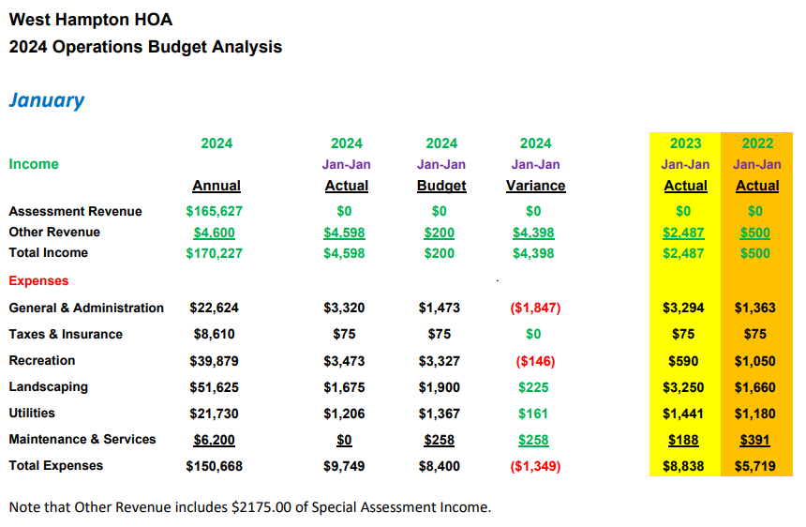

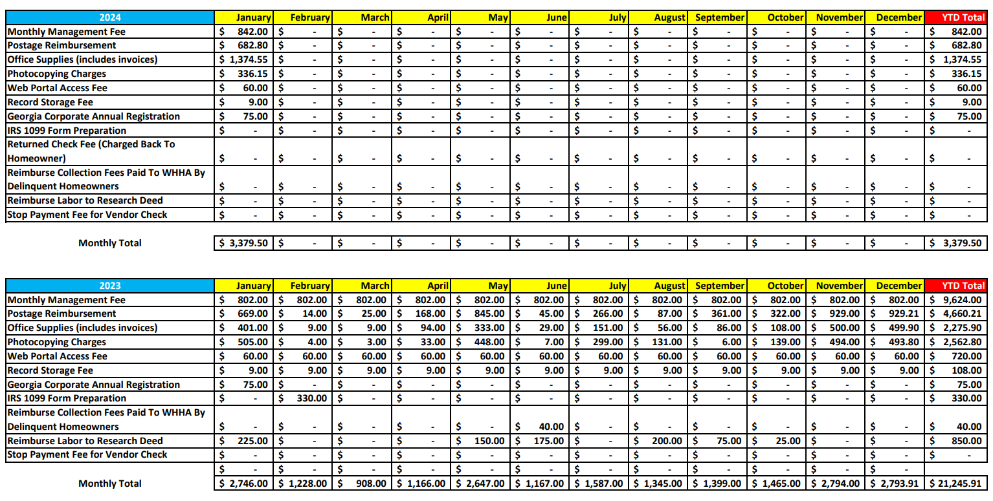
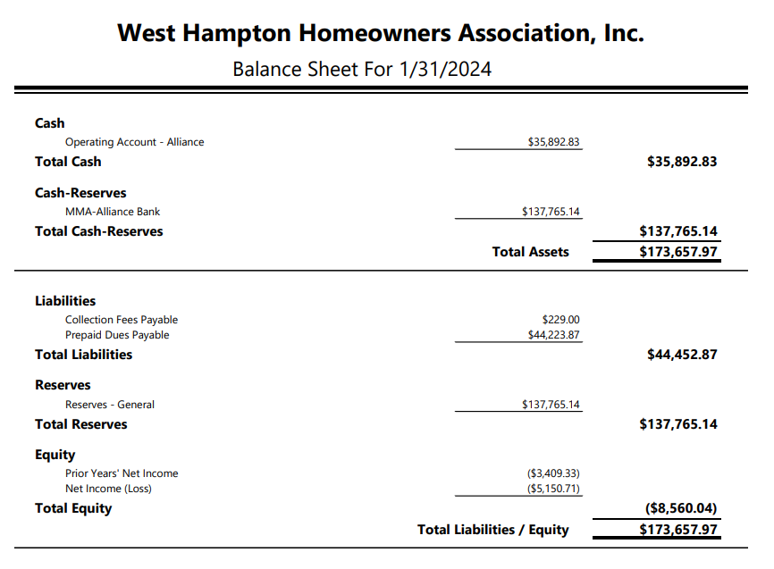
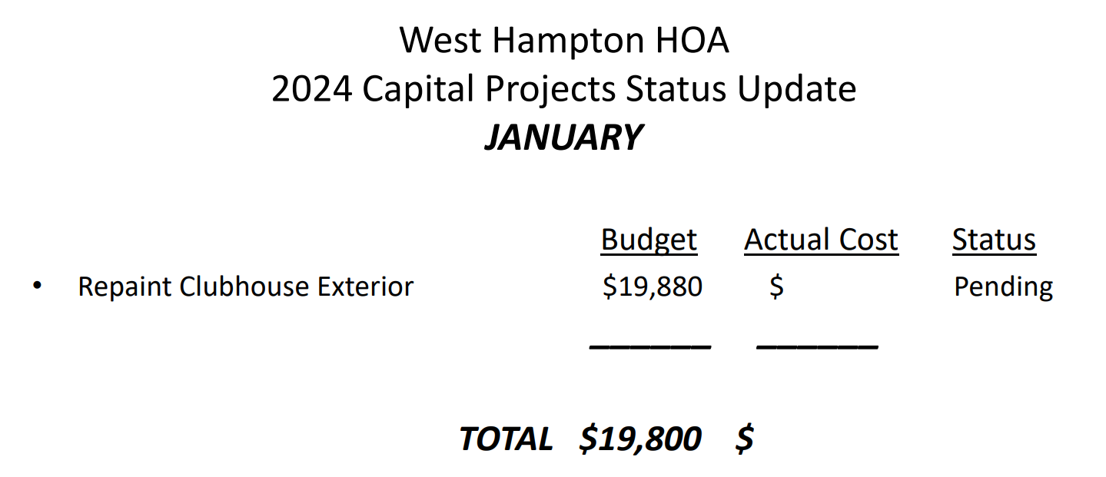
Clubhouse:
- There were eight clubhouse rentals in January and we have two rentals scheduled for February.

- The committee purchased some replacement decorative items for the clubhouse to replace normal wear and tear. Brenda Ray will be submitting the receipts for reimbursement. Cost was less than $200.

- In late January it was discovered that there was no hot water in the clubhouse. I called out A&S Plumbing to investigate and found that someone had turned the thermostat on the water heater off. When reset the water heater worked as expected. A&S Plumbing did not charge a call out or service charge.

- In early February we received a complaint regarding the security lighting on the back side of the clubhouse causing problems for our neighbors across Due West Rd. Steve Milby and James Fudge adjusted the security lighting to point lower towards our back deck, hopefully reducing the direct light exposure to our neighbors. Thank you, Steve and James.

- While adjusting the security lights, it was noticed that the upper tennis court lights were on in the middle of the day. Inspection found that someone had reset the permissive timer to incorrect times and had adjusted the time of day approximately 12 hrs from where it should have been set. I don’t know who would have done this or why. I purchased a padlock, reset the timer to the correct settings, and locked the timer box. This box is in the HVAC Room of the clubhouse across from the water heater. I will be changing the door lock on the storage room and reissuing keys to authorized individuals.
ACC Committee
2023 was a learning period. Since the POA status was initiated in 2022, the process of applying fees and fines was at times confusing. The ACC committee spent a lot of time working with Heritage on how to best communicate with WH association members. Rome & Associates informed the board of new laws regarding assessing fines, so the ACC stepped back to analyze the steps that needed to be taken. By the end of 2023, the procedures were moving more smoothly.
Currently, the ACC is working with Heritage to educate association members about the care of areas directly on property lines (i.e. grass, shrubs).
Pool Committee
Committee Members: Patty Ryan, chair; Brittani Lee Kelley, Gary Schweitzer, Steve Ryan
- Steve Ryan contacted Nautix. They will prep the pool for opening. Prep will include removing and storing the cover, stabilizing the chemicals, cleaning the pool, and other contractual duties.
- A new contract from Nautix is expected. The board should review and sign.
- The swimming pool will open on Saturday, May 4, 2024. Steve Ryan will set the gate keys to allow access to the pool and clubhouse bathrooms.
- The first practice for the Sharks will be Monday, May 6.
- A new swim program for young children will be started.
- The pool committee met on February 12th to discuss the rules that have been in place for the past few years. Some changes will be made.
- New signs will be ordered for placement at the pool area.
Playground
James Fudge has consulted with a company that may be able to help us preserve the current playground equipment for a couple of years. It is stressed that this would be a temporary measure, as the current wood structure will not be viable for much longer. The repairs will allow WH to plan for a permanent structure one to three years from now. Heritage will need this company to complete ‘Preferred Vendor’ forms in order to be paid for this project, approximately $4,500.00

Landscape
Hampton Landscape Co. has been hired to plant spring and winter plants in 2024. They will remove old plants as well ($5,800/year). The board was considering Pike Nursery for this task, but they did not include removal of old growth.
Sprinkalawn will again inspect three irrigation systems and the valve box by the pool entrance ($900 - $990). It is recommended that a couple of large rocks be placed on either side of one of the valve boxes to prevent it from continually being mowed over, as the valve is very expensive.
West Cobb will spread pine straw onto the common areas early in March.
The signs at the Burnt Hickory end of W. Hampton Dr. will be cleaned, repainted, and raised. Aho Fencing Co. will complete this for $1,900.
High School students volunteer hours. A couple of high schools in the area will be contacted to ask if WH qualifies as an association that could provide students with volunteer hours. Students (hopefully WH residents) could be used to help plant trees and in other ways.
Swim Team
Liz Chaney is the new chairperson of the Sharks swim team. Liz has established a team and changed the procedures to have greater clarity in the committee’s operation. It was recommended that the Sharks develop bylaws to aid in their transparency.
The Shark’s first practice session will be Monday, May 6th. Sign up will begin March first. This year, swim lessons for young children will be offered. Competition dates were not reported. The competitions bring many people to the pool and streets become congested. Last June, there were a few complaints about cars parking in certain areas. The swim team committee is working to alleviate issues in the future.
Social Media
Geri McCormick organized the WH website in preparation for new content. Dawn Parker has been updating the site with pictures and information in easier to find links. Steve will contact Dawn to see if there is any support that the board can offer her to help complete this project.
Welcome Committee
No homes sold in January 2024. There were no for sale signs on any home in the neighborhood.
Tennis Committee
There is no chairperson for tennis. This means that no one will be responsible for looking out for the condition of the courts or any problems that may arise with the court area.
Lisa Greenwood and Jamey Linard will continue to coordinate women’s and men’s competitions, respectively, with ALTA.
Social Committee: There is no formal social committee. The board will reach out to past participants in the Easter Egg hunt to see if they’re interested in helping this year.

